WTPR Softball - 2023
8U Pitching Machine Division Rules

- Always carry a copy of these rules to each game.

- This is a developmental league. We do not keep score or standings in this division.

- Coaches should keep track of their own game roster. There will be no exchange of rosters between teams.

- Maximum allowed game time is 1 hour 45 minutes or 6 innings. Whichever comes first.

- Each half inning ends after three outs are obtained or 5 runs are scored.

- FIELD SET UP:
a. The machine will pitch the ball from 35 feet at 35 MPH.
b. Double base will be used at first base.
c. Bases will be 60 feet apart.

- COACHES:
  - A defensive coach will assist with collecting balls behind home plate.
  - Two additional defensive coaches can be in the outfield helping players during the game. These coaches will serve as the umpires in the field.
  - The offensive pitching coach will NOT coach the players during the game. First and third base coaches are permitted.

- FIELDING & BATTING RULES:
  - No stealing bases
  - No dropped 3rd strike
  - No walks
  - No infield fly rule
  - No bunting
  - Outfielders cannot make force plays at any bases
  - Bat all rostered players
  - Free substitutions
  - One base on balls hit in the infield. Two bases on balls hit into the outfield.
  - No advancing on an overthrow.
  - Batted balls that hit the machine or pitching coach will be considered dead. Each runner will be awarded one base.

- Runners CANNOT leave the base until the ball is hit into play.
  - First offense a warning will be given
  - Second offense on will result in an out being called and removal of the offending runner from the bases.

- COACHES MUST WORK TOGETHER TO ENSURE GAME CALLS ARE BEING MADE FAIRLY. THIS IS AN INSTRUCTIONAL LEAGUE.
- EQUIPMENT:
  - All players on the field must wear a fielder’s mask.
  - Batters must have a helmet with a face cage on the front.
  - The balls are 11” leather softballs. No dimple balls or safety RIF balls will be used.
  - Catchers must wear full equipment. Equipment will be provided by WTPR Softball and will be located in the field equipment box.
  - Bats must have a USSSA/USA stamp on it. Bats can be composite.

- Each batter will be given 5 pitches to strike out or put the ball into play.
  - If the 5th pitch is batted foul, the batter will be awarded an additional pitch to put the ball in play.
  - If the batter does not put the ball into play, the batter is out.

- The player acting as the pitcher must stand on the first base side of the machine and start with one foot in the circle, behind the pitching line, until the ball is pitched.

- Ten fielding positions will be played on defense.

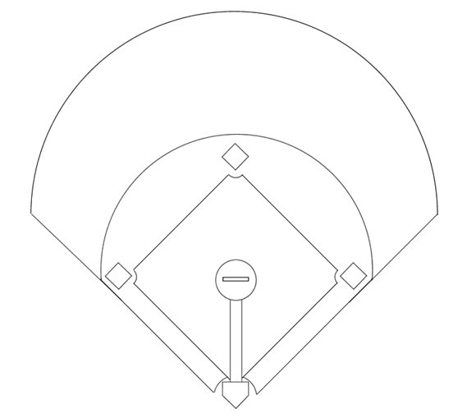
2 – Catcher (C)
10 – Right Field (RF)
9 – Right Center (RCF)
8 – Left Center (LCF)
7 – Left Field (LF)
6 – Shortstop (SS)
5 – 3rd Base (3B)
4 – 2nd Base (2B)
3 – 1st Base (1B)
1 – Pitcher (P)

- Outfielders must play equally distanced apart, in the grass, at least 5 feet behind the infield dirt. An outfielder cannot make a force play at any base (they cannot tag second after fielding the ball).

- Infielders should play in their true positions with minimal shifting. Playing the fielders slightly in front of the base path is okay. Bringing the fielders in to “cherry pick” hits is not allowed.

- This is a developmental/instructional league. ALL players must be rotated to new positions each inning throughout the game and play a minimum of 2 innings in the infield. No player should sit the bench on defense more than one inning each game. Every effort should be made to play each player in a new position each inning (ex: 5 innings played = five different positions). No player should play the same position more than two innings per game (cannot be back-to-back innings).

- All available players will bat in the lineup.

- Any bat which flies from the batter’s hands, and endangers the catcher or other fielders, will cause a warning to the offensive team. On the 2nd offense, the batter will be declared out. The ball will be dead, and all runners will return to the last base they occupied.

- Managers can call a timeout during the game. One (1) timeout per inning allowed.

- Since this is a developmental league, games can be played shorthanded. A minimum of 7 players is required in order to compete. If a team cannot field 7 players, the game will be rescheduled for a later date.

